**What are the various kinds of alerts provided by Web Applications?**

As we discussed, there are various types of alerts that the developers can implement on web applications. Each of these alerts/popups needs different kinds of actions to handle these alerts. Let's see what these different types of alerts that the web applications provide are:

* ***Simple alert****: These alerts are just****informational****alerts and have an****OK****button on them. Users can click on the****OK****button after reading the message displayed on the alert box. A simple alert box looks like below:*

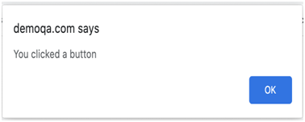

* ***Prompt Alert***: *In Prompt alerts, some****input requirement****is there from the user in the form of text needs to enter in the alert box. A prompt alert box is displayed like below, where the user can enter his/her username and press the****OK****button or****Cancel****the alert box without entering any details* .

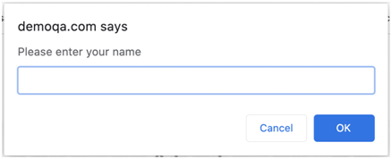

* ***Confirmation Alert****: These alerts****get some confirmation****from the user in the form of****accepting****or****dismissing****the message box. They are different from prompt alerts in a way that the user cannot enter anything as there is no text-box available. Users can only read the message and provide the inputs by pressing the****OK/Cancel****button*.

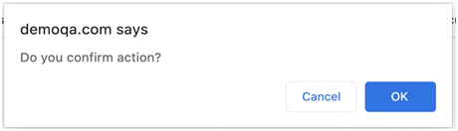

To handle JavaScript alerts, Selenium Web Driver provides the package org.openqa.selenium.Alert and exposes the following methods:

• Void accept(): This method clicks on the 'OK' button of the alert box.

driver.switchTo( ).alert( ).accept();

• Void dismiss(): We use this method when the 'Cancel' button clicks in the alert box.

driver.switchTo( ).alert( ).dismiss();

• String getText(): This method captures the message from the alert box.

driver.switchTo().alert().getText();

• Void sendKeys(String stringToSend): This method sends data to the alert box.

driver.switchTo().alert().sendKeys("Text");